Thread List
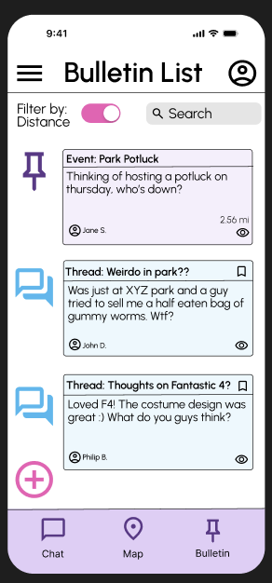

Viewing Thread
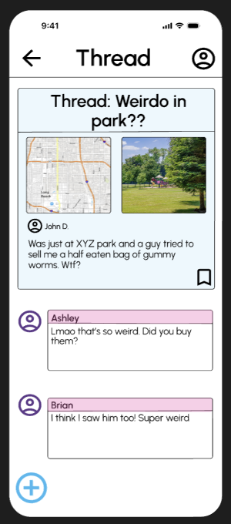

Color Palette and extras:
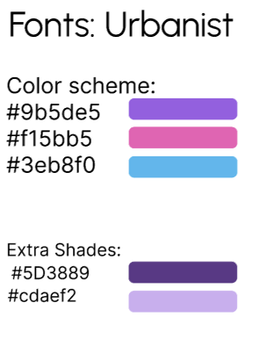
I chose these colors because I had noticed that they were prominent colors within Instagram and Tik Tok, both very popular platforms. These colors provide a mix of warm and cool tones, while also being vibrant. Usually, when I see these colors in other apps, they call to my attention. I chose some extra shades from the purple so that we can differentiate between some of the buttons and backgrounds. I also got inspiration from our past layout but changed around some buttons and their positioning. I also made sure to use specific icons and colors for the threads and events. This way it’s easier to differentiate between the two and those who are colorblind can also know the difference using the icons. Additionally, I made the bookmark and “view” button into an eye and bookmark icon. Through these icons, there’s less clutter on the screen and the icons are intuitive. I got all of these icons from google, but we could also use custom icons, although I am not sure how much time that would take.
Figma Link: https://www.figma.com/design/x5GJ9VlaAzCCgAHsNDjG8T/Citlally-Draft?node-id=0-1&t=ucB3KZ46VUdvYjGI-1

